**Question 1 -> Write a java program that takes three numbers from the user and print the greatest number.**

**// SOURCE CODE**

import java.util.Scanner;

class GreatestNumber{

public static void main(String args [ ] ) {

Scanner sc = new Scanner(System.in);

int n1 , n2 , n3;

System.out.print("ENTER NUMBER 1 : ");

n1 = sc.nextInt();

System.out.print("ENTER NUMBER 2 : ");

n2 = sc.nextInt();

System.out.print("ENTER NUMBER 3 : ");

n3 = sc.nextInt();

System.out.print(“The Greatest Value: “);

if ( n1 > n2 && n1 > n3){

System.out.println(n1);

}

else if( n2 > n1 && n2 > n3){

System.out.println(n2);

}

else if( n3 > n1 && n3 > n2){

System.out.println(n3);

}

}

}

**OUTPUT:**

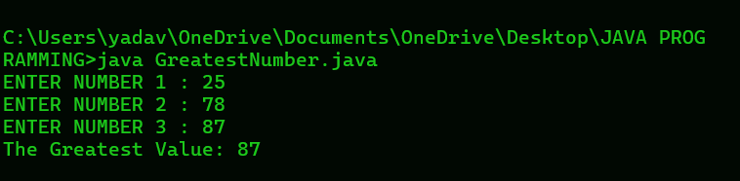

**Question 2 - > Write a java program that reads a floating number and prints "Zero" if the number is zero. Otherwise print "positive" or "negative" . Add "small" if the absolute value fo the number is less than 1, or "large" if it exceeds 1 , 000 , 000.**

**// SOURCE CODE**

import java.util.Scanner;

class AbsoluteValue{

public static void main(String args [ ] ) {

Scanner sc = new Scanner(System.in);

float n;

System.out.print("ENTER ANY NUMBER: ");

n = sc.nextFloat();if ( n == 0 ) {

System.out.println("Zero");

}

else if( n > 0 ){

System.out.print("Positive ");

}

else {

System.out.print("Negative");

}

if ( Math.abs(n) < 1) {

System.out.println("small");

}

else if(Math.abs(n) > 1_000_000){

System.out.println("large");

}

else{

System.out.println();

}

}

}

**OUTPUT:**

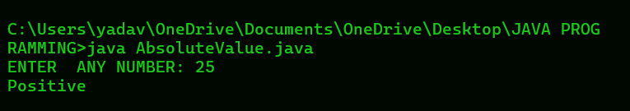

**Question 3 -> Write a java program that reads two floating-point numbers and test whether they are the same up to three decimal places.**

**// SOURCE CODE**

import java.util.Scanner;

class DecimalCompare{

public static void main(String args [ ] ){

Scanner sc = new Scanner(System.in);

double n1 , n2;

System.out.print("ENTER FIRST FLOATING NUMBER: ");

n1 = sc.nextDouble();

System.out.print("ENTER SECOND FLOATING NUMBER: ");

n2 = sc.nextDouble();

n1 = Math.round( n1 * 1000.0) / 1000.0;

n2 = Math.round( n2 * 1000.0) / 1000.0;

if ( n1 == n2 ) {

System.out.println("They are same " );

}

else {

System.out.println("They are different");

}

}

}

**// OUTPUT**

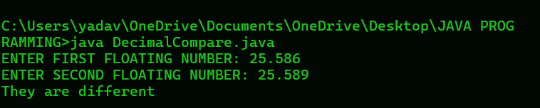

**Question 4 -> Write a java program to find the number of days in a month.**

**// SOURCE CODE**

import java.util.Scanner;

class NumberMonth{

public static void main(String args [ ] ) {

Scanner sc = new Scanner (System.in);

/

int M , Y , daysInmonth;

String MonthName;

System.out.print("ENTER A MONTH NUMBER : ");

M = sc.nextInt();

System.out.print("ENTER A YEAR: ");

Y = sc.nextInt();

switch(M){

case 1:

MonthName = "January";

daysInmonth = 31;

break;

case 2:

MonthName = "February";

if( (Y % 4 == 0 && Y % 100 != 0 ) || ( Y % 400 == 0)){

daysInmonth = 29; // Leap year

}

else{

daysInmonth = 28; // Non- leap year

}

break;

case 3:

MonthName = "March";

daysInmonth = 31;

break;

case 4:

MonthName = "April";

daysInmonth = 30;

break;

case 5:

MonthName = "May";

daysInmonth = 31;

break;

case 6:

MonthName = "June";

daysInmonth = 30;

break;

case 7:

MonthName = "July";

daysInmonth = 31;

break;

case 8:

MonthName = "August";

daysInmonth = 30;

break;

case 9:

MonthName = "September";

daysInmonth = 31;

break;

case 10:

MonthName = "October";

daysInmonth = 30;

break;

case 11:

MonthName = "November";

daysInmonth = 31;

break;

case 12:

MonthName = "December";

daysInmonth = 30;

break;

default:

MonthName = "Invalid";

daysInmonth = 0;

System.out.println("Invalid month number");

}

System.out.println(MonthName + " " + Y + " " + "has" + " " + daysInmonth + " " + "days");

}

}

**// OUTPUT:**

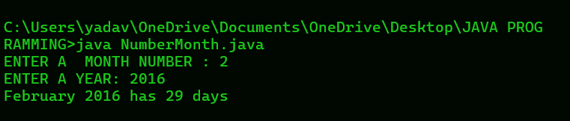

**Question 5 -> Write a java program that requires the user to enter a single character from the alphabet. Print Vowel or Consonant, depending on user input. if the user input is not letter ( between a and z or A and Z ) , or is a string of length > 1, print an error message.**

// **SOURCE CODE**

import java.util.Scanner;

class CheckCharacter {

public static void main(String[] args) {

Scanner sc = new Scanner(System.in);

System.out.print("ENTER ANY CHARACTER: ");

String str = sc.nextLine();

char c = str.charAt(0);

if (str.length() > 1 || !Character.isLetter(str.charAt(0))) {

System.out.println("Error: Please enter a single alphabet character.");

} else {

if (c == 'a' || c == 'e' || c == 'i' || c == 'o' || c == 'u' ||

c == 'A' || c == 'E' || c == 'I' || c == 'O' || c == 'U') {

System.out.println("Input letter is a vowel");

} else {

System.out.println("Input letter is a consonant");

}

}

}

}

// **OUTPUT:**

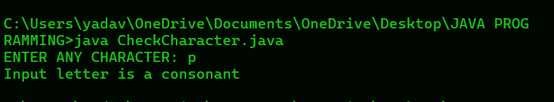

**Question 6 -> Write a java programe that takes a year from the user and prints whther it is a leap year or not.**

// **SOURCE CODE**

import java.util.Scanner;

class CheckLeapYear{

public static void main(String args [ ] ) {

Scanner sc = new Scanner(System.in);

System.out.print("ENTER ANY YEAR: ");

int y = sc.nextInt();

if ( ( y % 4 == 0 && y % 100 != 0) || ( y % 400 == 0)) {

System.out.println( y + " is a leap year");

}

else {

System.out.println( y + " is not a leap year");

}

}

**// OUTPUT:**

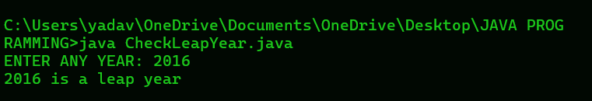

**Question 7 -> Write a java program in java to input 5 number from the keyboard and find their sum and average**

**// SOURCE CODE**

import java.util.Scanner;

public class AverageSum {

public static void main(String[] args) {

Scanner sc = new Scanner(System.in);

int sum = 0;

int numberOfInputs = 5;

float average

System.out.println("Enter " + numberOfInputs + " numbers:");

for (int i = 1; i <= numberOfInputs; i++) {

System.out.print("Enter number " + i + ": ");

int number = sc.nextInt();

sum += number;

}

average = sum / numberOfInputs;

System.out.println(" The Sum of 5 no. is: " + sum);

System.out.println(" The Average is: " + average);

}

}

**// OUTPUT:**

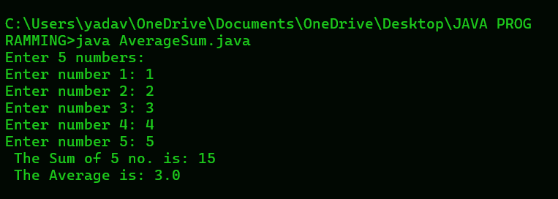

**Question 8 -> Write java program that displays the sum of n odd natural number.**

**// SOURCE CODE**

import java.util.Scanner;

class OddNatural{

public static void main(String args [ ] ) {

Scanner sc = new Scanner(System.in);

int n , sum = 0 , count = 0;

System.out.print("INPUT NUMBER OF TERMS: ");

n = sc.nextInt();

for ( int i = 1 ; count < n; i += 2 ) {

System.out.println(i );

oddnumber = 2 * i - 1;

sum += i;

count++;

}

System.out.println("The Sum of odd natural number upto 5 term is: " + sum);

}

}

**// OUTPUT:**

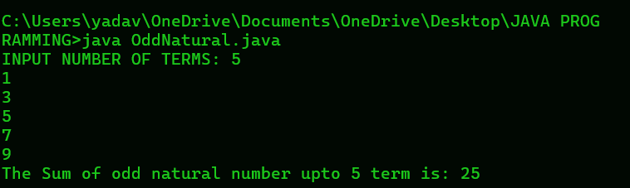

**Question 9 -> Write a program that accepts three numbers from the user and prints "increasing" if the numbers are in increasing order, "decreasing" if the numbers are in decreasing order, and "Neither increasing or decreasing order" otherwise.**

**// SOURCE CODE**

import java.util.Scanner;

public class NumberOrder {

public static void main(String[] args) {

Scanner sc = new Scanner(System.in);

System.out.print("Enter the first number: ");

int num1 = sc.nextInt();

System.out.print("Enter the second number: ");

int num2 = sc.nextInt();

System.out.print("Enter the third number: ");

int num3 = sc.nextInt();

if (num1 < num2 && num2 < num3) {

System.out.println("increasing order");

} else if (num1 > num2 && num2 > num3) {

System.out.println("decreasing order");

} else {

System.out.println("Neither increasing nor decreasing order");

}

}

}

**// OUTPUT:**

